6.98: a) 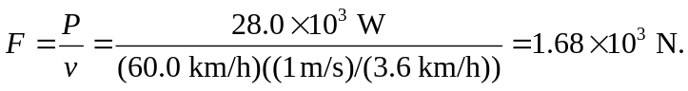

b) The speed is lowered by a factor of one-half, and the resisting force is lowered by a factor of 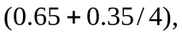 and so the power at the lower speed is

c) Similarly, at the higher speed,

